**Bottom-Up Analysis:**

Screenshot of running code:

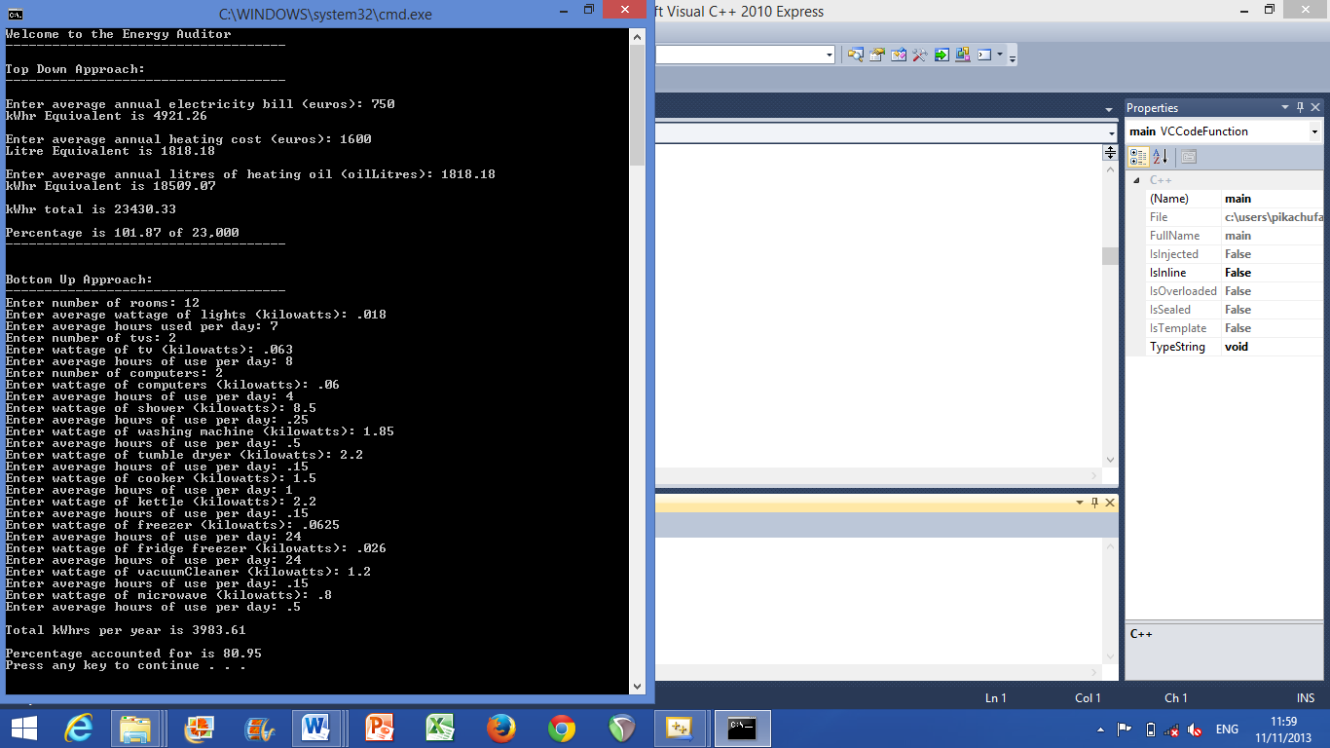

**Summary of findings:**

From writing this code and running it I was able to account for 80.95% of our electrical usage per annum.

I accomplished this by calculating the kWhr usage for various household appliances. These included:

2 43 inch plasma TVs, 2 computers, an electric shower, a washing machine, a tumble dryer, an electric cooker, a small chest freezer, a fridge freezer, a vacuum cleaner, a microwave and a kettle.

Given that not all items which require electricity to run were used, just the main ones, the percentage accounted for which I calculated was relatively accurate but not fully accurate, only 80.95% accurate.

For my overall percentage accounted for to be even higher I would need to do a more detailed analysis including all the electrical appliances throughout the house.

Also given all the values were averages and not exact figures for one year I am pleased with my percentage of success for this code.